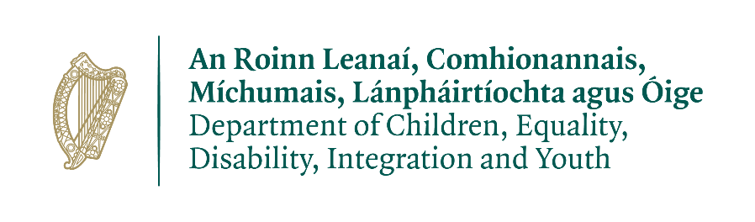

Capacity Building Grant and Hub na nÓg Training to support implementation of the National Framework for Children and Young People’s Participation in

Decision-making at the level of everyday practice

Introduction and Aims
The Department of Children, Equality, Disability, Integration and Youth (DCEDIY) has established a fund to support implementation of the National Participation Framework for Children and Young People’s Participation in Decision Making [the Framework] (2021) within everyday spaces and settings where practitioners work directly with children and young people.

The Framework supports departments, agencies and organisations in a journey towards improving their practice in listening to children and young people and giving them a voice in decision-making. It focuses on children and young people’s individual and collective participation in decision-making, whether that takes place in person, online or both. Individual decisions are those that affect one child, such as decisions about the health, education or social care that they receive. Collective decisions are those that affect children as a group in everyday settings like schools, early learning and care services, child and youth services, youth clubs and projects, and creative, artistic and sporting activities, or in the development of national and organisational projects, programmes, services, research, legislation and policies.

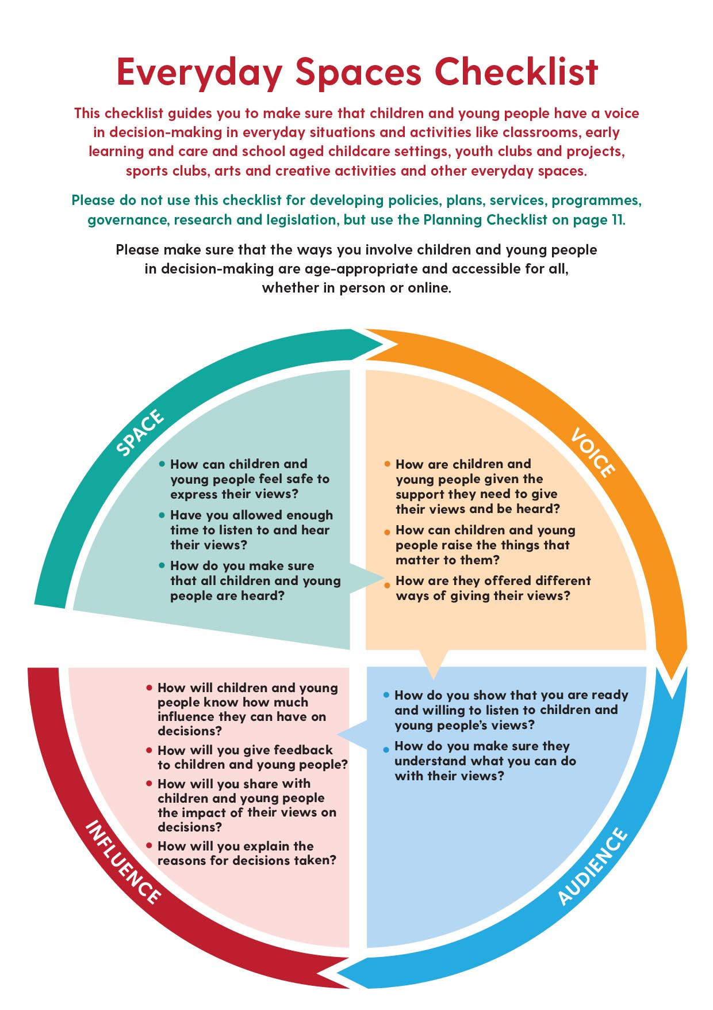
This stage of the capacity building grant will focus on everyday contexts and the application of the everyday spaces checklist. Please find the everyday spaces checklist below:
The vision of the Framework is participation with purpose. Participation with purpose is about two distinct but interrelated factors, the purpose or objective of your organisation and the purpose or objective of involving children and young people in decision-making. It is important to ensure that the purpose of involving children and young people in decision-making is to give them a voice on day-to-day activities and practices, or on the development of projects, programmes, services or policies that are central to the objectives and role of your organisation. At the heart of participation with purpose is ensuring that when children and young people are involved in decision-making, their views are listened to, taken seriously and given due weight, with the intention that these views will influence the outcome or initiate change.
Grant and Training objectives
The objective of the grant and training is to support organisations to give children and young people a voice in decision-making in their day-to-day practices, services, projects, programmes or activities.

- Eligible organisations*
The fund and training is open to organisations that provide services, programmes or projects to children and young people from the following sectors:

- Tusla Registered Early Learning Care and School-Age Childcare providers.
- Arts Organisations** (Working directly with Children and Young People)
- Youth Services
- Youth Justice
- Traveller Service Providers
- Disability Service Providers
- Homeless Service Providers

*The criteria for eligible sectors will be reviewed in subsequent years.
**Arts Organisations supported under the LCYP pilot programme are not eligible to apply.
In the event that demand exceeds funding and training resources available, consideration will be given to allowing organisations to reapply under this fund in 2022.

- Funding Packages
All successful applicants must be available to attend training provided by Hub na nÓg. This training will be based on listening to children and young people and involving them in decision making in their day-to-day practices, services, projects, programmes or activities, and the development of resources based on the training.
Funding is awarded based on which category applies to your training requirements:
Category 1: Funding available up to €2,000 (Small Sized Organisations, Small to Medium scale rollout of participation framework posters and materials.)

Category 2: Funding available up to €5,000 (Medium Sized Organisations, In-house training or professional development staff, Medium Scale rollout of participation framework posters and materials.)

Category 3: Funding available up to €10,000 (Large National Organisations, In-House training or professional development staff, large scale rollout of participation framework posters and materials.)

Organisations should select the package that fits the size of the organisation along with the following considerations:

- The number of practitioners who could benefit from the training options outlined in Section 3.
- The project, sessions, or services and the children and young people that could benefit from the fund outlined in Section 4.
- The organisation’s capacity to develop and use the resources outlined in Section 5.2 and 5.3

- Training Options
Eligible organisations are invited to apply for training under options 3.1 or 3.2 below:

  - Training for up to five practitioners (subject to availability and demand)
from your organisation on how to use the Participation Framework Everyday Spaces Checklist to give children and young people a voice in decision-making in everyday settings such as early learning and care settings, child or youth clubs, child or youth projects and other service provision. This training will delivered by members of the Hub training panel between September and November 2021. This option may be suitable for smaller organisations who do not have in-house training or development staff members.

OR

  - Training of trainers for up to three individuals in your organisation who are part of a training or development team or have a training qualification.
This training will upskill staff from your organisation to deliver training to practitioners on how to use the Participation Framework Everyday Spaces Checklist to give children and young people a voice in decision-making in everyday settings (early learning and care settings, child or youth clubs, child or youth projects and other service provision). This training of trainers will be delivered by members of the Hub training panel between September and November 2021. This option may be suitable for medium to large organisations that have an in-house training and development staff member or team.

- Application requirements
Funding applications must outline how the receipt of funding for training, resources and undertaking practice tasks will add value in driving implementation of the National Framework for Children and Young People’s Participation in Decision Making within the organisation.

Organisations applying for 3.1 (Training for Practitioners)
Please provide details on:
- The rationale and need for training and resources to more effectively listen to children and young people and involve them in decision-making in the day-to-day practices, services, projects, programmes or activities of the organisation
- The number of practitioners to be trained, including the settings or projects in which those practitioners work
- The number of children or young people who will benefit from the fund, including details on the settings or projects they attend
- The number of children or young people who are ‘seldom heard’* that will benefit from the fund, including details on the settings or projects they attend
- The anticipated use of posters and other child and youth voice resources
- The anticipated added value of this fund in supporting implementation of the Participation Framework (for practitioners, for children and young people and for the organisation)

Organisations applying for 3.2 (Training of Trainers)
Please provide details on:
- The rationale and need for training of trainers and resources to support practitioners in your organisation to more effectively listen to children and young people and involve them in decision-making in the day-to-day practices, services, projects, programmes or activities
- The number of practitioners to be trained by training and development teams that receive Hub training, including the settings or projects in which those practitioners work
- The number of children or young people who will benefit from the fund, including details on the settings or projects they attend
- The number of children or young people who are ‘seldom heard’* that will benefit from the fund, including details on the settings or projects they attend
- The anticipated use of posters and other child and youth voice resources
- The anticipated added value of this fund in supporting implementation of the Participation Framework (for practitioners, for children and young people and for the organisation)
*Seldom Heard: These are groups of children and young people that organisations struggle to include in decision-making. Among others, these include LGBTI+ children and young people, those with disabilities, those from ethnic minorities, Traveller and Roma children and young people, and young carers. The barriers to involving these groups in decision-making include language barriers, access barriers (including digital access), communication barriers and cultural barriers.
Organisations that are awarded funding will be required to submit a report on how the granted funding was used at the end of the funding cycle.

- Resources that are eligible under the fund

The costs associated with attending training and the resources outlined below are eligible under the fund but funded organisations must commission the development of these resources after the delivery of Hub na nÓg training.

5.1 Costs associated with attending training:
- Travel, if applicable. A flat-rate contribution of €20 (within 50km of Dublin City Centre) or €40 per person (Outside 50km of Dublin City Centre) will be available for travel costs.
Further details on training arrangements and the coverage of expenses will be provided to successful applicants. In-person training is contingent on the latest public health restrictions in relation to Covid-19’
- And/or Cost of providing substitute for staff member attending training. (Evidence of rate required and will be paid retrospectively)

5.2 The print of posters, stickers, notepads and mouse or desk pads or the development of online resources.
The printing of resources depicting the Framework Every Day Spaces Checklist and/or the development of online resources depicting the Framework Every Day Spaces Checklist to be displayed and used in settings where services, projects, clubs and programmes are provided for children and young people. Options for printed resources include posters, stickers, notepads and mouse or desk pads. A template for printed resources, with space for organisations to add their own branding will be provided to organisations that are granted funding. Funded organisations must commission the print and online development of products in a timeframe that complements the delivery of training
5.3 The development of a Voice Toolkit of resources to help practitioners to effectively listen to children and young people and take their views seriously in the setting and space in which they work with children or young people.
Applications can include resources such as:
- Disposable cameras
- Flip charts
- Purple walls
- Blu-tack
- Post-its
- Sharpie markers
- Stickers
- Coloured card
- Coloured paper
- Voting boxes
- Sticky dots or other sticky shapes
- Resources that support children and young people with disabilities to have a voice
- Other resources that support children and young people to have a voice

- Training for Grantees
All successful applicants must be available to attend training provided by Hub na nÓg. This training may take place online or in a central or regional locations or be provided in a blended model of online/on location, subject to ongoing Covid-19 restrictions and DCEDIY Guidelines.

Content of the training
- Basic theoretical training on the rights and policy context for the right of children and young people to a voice in decision-making
- Training on the use of the Framework with a particular focus on the Everyday Spaces checklist
- Practice tasks that support practitioners in the use of the Everyday Spaces Checklist

Practice Tasks
Practice tasks to support implementation of the Framework based on guidance from Hub na nÓg training to demonstrate improved practice and tangible outcomes.

Reflective practice diary
Training participants will be given guidance on using the Everyday Spaces Checklist to keep a reflective practice diary for a month after the Hub training, using the guidance and diary template provided at the training in order to:
- Record new things you do to ensure space, voice, audience and influence to the children or young people
- Record the impact on your daily practice as a result of using the Everyday Spaces Checklist
- Record the impact on the group of children or young people of using the Everyday Spaces Checklist
- Record the impact on individual children or young people of using the Everyday Spaces Checklist
Development of a child/youth charter for your everyday setting or space
Training participants will be given guidance on the development of a child/youth charter version of the Everyday Spaces Checklist (In partnership with children and young people) outlining ‘How I expect to be listened to in my group/club/project/etc.’ (children and young people will come up with their own titles)

This guidance will be on how to:
- Use the consultation/discussion methods outlined in the Hub training
- Support the children and young people to design and make their own charter using the resources from your Voice Toolkit
- Community of Practices
As part of ongoing support for organisations that have received training as part of the Capacity Building Grant to support implementation of the National Framework for Children and Young People’s Participation in Decision-making at the level of everyday practice, organisations will be offered the opportunity to attend community of practice meetings with Hub training and education staff.
There will be two community of practice meetings, one for those who have received training for trainers, and one for those who have received the training for practitioners. These meetings will give individuals the opportunity to discuss examples of practice, share ideas and seek further support and clarification if necessary. The dates and times of these meetings will be communicated after training is complete.

- Submission of Application and Closing Date
Submissions will be sent to the Department of Children, Equality, Disability, Integration and Youth. Applications will open on Thursday 10th of June 2021.
Applications must be sent by close of business, Monday 5th of July to: citizenparticipation@equality.gov.ie

- Appraisal Process and Marking System
Award Criteria | Maximum  score | Minimum  Score required
Demonstration of Need  Applicants must clearly identify and demonstrate the need for funding. This should include providing details of the following:  - The rationale and need for training to more effectively consider the voice of children and young people and involve them in decision-making in the day-to-day practices, services, projects, programmes or activities of the organisation.  - The rationale and need for associated resources to help practitioners to effectively listen to children and young people and take their views seriously in the setting and space in which they work with children or young people. | 40 | 20
Reach:  Applications should clearly define the level of need demonstrated of young people/children provided for by the service, including the need of seldom-heard* and difficult to reach Children and Young People. Including the following:  - Number of Children and Young People that your organisation currently engages with.  - Number of practitioners within your organisation.  - Further information on your organisation’s reach to seldom heard and difficult to reach Children and Young People.  *Seldom Heard: These are groups of children and young people that organisations struggle to include in decision-making. Among others, these include LGBTI+ children and young people, those with disabilities, those from ethnic minorities, Traveller and Roma children and young people, and young carers. The barriers to involving these groups in decision-making include language barriers, access barriers (including digital access), communication barriers and cultural barriers. | 40 | 20
Outcomes:  Applications should demonstrate commitment to engage in implementation of the Participation Framework and to outline what your organisation expects to achieve on receipt of training and associated resources. | 40 | 20

- Decisions
A Selection Committee within the Department of Children, Equality, Disability, Integration and Youth will review all submitted applications and grade each section in accordance with the criteria. Final recommendations on award of the grants will be made by this Selection Committee and submitted to the Minister for Children, Equality, Disability, Integration and Youth for consideration.
Decisions on grant awards will be notified to the services/projects and organisations by the Department of Children, Equality, Disability, Integration and Youth.
The payment of the grant, related financial administration and any other regulatory and/or financial governance requirements and reporting will be dealt with according to Circular 13/2014.
No cost or part thereof, of any element of the proposed application can be previously expended before approval date i.e. before the date on which final funding approval is confirmed.

- Evaluation of the Initiative
The Department of Children, Equality, Disability, Integration and Youth will arrange evaluation of the Initiative to measure its impact. All successful services will be requested to participate in the evaluation process.

Department of Children, Equality, Disability, Integration and Youth
Data Privacy Statement
The Department of Children, Equality, Disability, Integration and Youth is committed to protecting the rights and privacy of individuals in accordance with both European Union and Irish data protection legislation. We place high importance on the correct, lawful and fair handling of all personal data, respecting the legal rights, privacy and trust of all individuals with whom we deal. Please find the department’s complete privacy statement HERE

APPLICATION FORM
To view the National Framework for Children and Young Peoples Participation in Decision-making please click here.
IMPORTANT NOTES

- Grants awarded must be fully spent in 2021.

- Applications should only be submitted for funding of projects which can be fully completed, vouched for and accounted for in 2021.

- Any money unspent by a grantee by December 31st 2021 must be surrendered to the Department of Children, Equality, Disability, Integration and Youth; the Department will recover money from any grantee found in breach of this requirement.

- Completed applications should be submitted via email to: citizenparticipation@equality.gov.ie

- Closing Date for applications: close of business Monday 5th of July.

- Service/Project Details

  - Name of Service / Project

1.2 Address of premises

1.3 Person to be contacted in respect of this application (A senior member of your organisation)
Name |  | Position

1.4 Address for correspondence
Charity Registration No.  (If applicable)  Number |  | Eircode
CRO Number
Tax Reference Number |  | Tax Clearance Access Number

1.5 Contact details.
Landline |  | Mobile
E-mail:
Website
Social media

1.6 Bank details
Please state:
Name of bank:
Address of Bank:
IBAN Number:
IBIC number:

- Details of Grant Sought

  - Please choose which category applies to your organisation:
- Category 1 (Funding up to €2,000)
- Category 2 (Funding up to €5,000)
- Category 3 (Funding up to €10,000)

  - Please identify which training option suits your organisation’s need:
- Training for up to five practitioners from your organisation.
(Subject to Availability & Demand)
Please provide the number of practitioners you expect to attend here: _______

- Training of trainers for up to three individuals in your organisation who are part of a training or development team or have a training qualification.
Please provide the number of trainers you expect to attend here: _____

  - Please specify which category below best fits your organization:
- Tusla Registered Early Learning Care and School-Age Childcare Providers
- Arts Organisations (Working Directly with Children and Young People)
- Youth Services
- Youth Justice
- Traveller Service Providers
- Disability Service Providers
- Homeless Service Providers
- Other (please specify) _____________________________________________

  - Please provide a brief summary of your organisation's aims, objectives, methodologies and services to young people (Max. 300 words)

  - Please identify and demonstrate the need for funding with regard to training and associated resources to effectively listen to children and young people in decision-making in the day-to-day practices, services, projects, programmes or activities of the organisation.
(Max. 300 words)

  - Please outline the reach of your organisation to Young People/Children, including the need of seldom-heard and difficult to reach Young People/Children. Please include the number of Children and Young People that your organisation currently engages with and the number of practitioners within your organisation. (Max. 300 words)

  - Please describe your organisation’s commitment to giving children and young people a voice in decision-making in their day-to-day practices, services, projects, programmes or activities and the outcomes that you as an organization expect to achieve on receipt of training and associated resources.
(Max. 300 words)

- Financial Details
3.1 What is the total Grant Amount for which you are applying?
€

3.2 Estimated cost associated with attending training (Including Breakdown)
Flat Rate of €20 per day (within 50km of Dublin City Centre) or €40 per day (outside 50km of Dublin City Centre) and/or cost of substitute staff member.

3.3 Estimated cost of resources as listed in 5.2 (The print of posters, diary inserts and other products or the development of online resources) of the application guidance booklet. (Including Breakdown)
3.4 Estimated cost of resources as listed in 5.3 (The development of a Voice Toolkit of resources) of the application guidance booklet. (Including Breakdown)

DECLARATION OF ACCEPTANCE
On behalf of our Organisation/Service/Project, we apply for a once-off grant for the purpose stated above and declare that the information given in this application is true and complete to the best of our knowledge and belief. We consent to the Department of Children, Equality, Disability, Integration and Youth making enquiries to a third party if necessary regarding details of the funding application.

We understand that information supplied in or accompanying this application may be made available on request under the Freedom of Information Acts 1997 and 2003. We also understand that making application is no guarantee of funding.
We also accept, as a condition for the award of a grant, that it involves no commitment to any other grants from the Department of Children, Equality, Disability, Integration and Youth (DCEDIY) or from any Government Department. The project sponsors are agreeable to have the project monitored by DCEDIY and to allow access to its premises and records, as necessary, for that purpose.
If funding is approved, we agree and confirm that we will manage the grant in accordance with the conditions. We agree to seek value for money and to abide by the Public Procurement guidelines. The funds will be applied for the purposes set out in our application and we undertake that funding from any other source will not be used for the same purpose. In the event that we are unable to spend the grant for the purposes set out in our application, we agree to return the grant. We understand that the DCEDIY may seek the refund of the grant if we fail to comply with these conditions.

We acknowledge that any funds awarded are subject to such funds being available to the Department and that they must be used in the year(s) the grant is awarded and for the purpose stated and not to replace existing funding and we will acknowledge the support we have received from the Department of Children, Equality, Disability, Integration and Youth in all publicity in relation to our project.

We hereby apply for grant funding and accept the above Terms and Conditions:

Signed: __________________________________________
Position: _________________________________________
Date: ____________
Department of Children, Equality, Disability, Integration and Youth
Data Privacy Statement
The Department of Children, Equality, Disability, Integration and Youth is committed to protecting the rights and privacy of individuals in accordance with both European Union and Irish data protection legislation. We place high importance on the correct, lawful and fair handling of all personal data, respecting the legal rights, privacy and trust of all individuals with whom we deal. Please find the department’s complete privacy statement HERE

