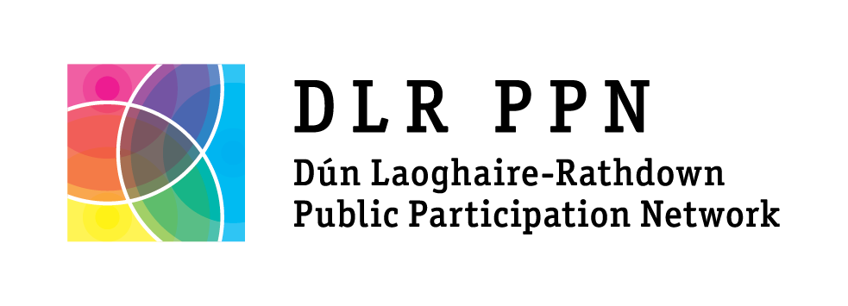

Membership Application Form
Online applications can be made at www.dlrppn.ie/register

What is the name of your group / organisation?

Tell us a bit about your group / organisation and its aims:

Do you consider your main activities to be? (Tick one)

☐ Community: (Local Development, Sports, Arts, Residents, Social groups etc.)
☐ Environmental : (Focused on protecting the environment and sustainability)
☐ Social Inclusion : (Focused on people experiencing disadvantage and inequality)
In which electoral area are your activities mainly focused? (Tick one)

☐ Blackrock ☐ Killiney-Shankill
☐ Dundrum ☐ Stillorgan
☐ Dun Laoghaire ☐ County-wide
☐ Glencullen-Sandyford ☐ National

How is your group structured? (Tick one)

☐ Affiliated ☐ Association ☐ Charity
☐ Committee ☐ Co-operative ☐ Limited company
☐ Set of Rules ☐ Trust ☐ None
☐ Other (please describe) ____________________________________________________________________________
What year was your group/ organisation established? _________________
Is your group governed by rules or a constitution? YES NO
How many members do you have? __________
How many paid staff does your organisation have? _________
How many volunteers does your group / organisation have? ____________

What is your website address? _________________________________________
What is your Facebook page? __________________________________________
What is your Twitter account? __________________________________________

Main address for correspondence:

Name of Main Contact:

Main Contact email address:

Main Contact phone number:

Alternate Contact name:

Alternate Contact email address:

Alternate Contact phone number:
Data Protection information:

How will DLR PPN use your personal data?
Under the provisions of the Local Government (Reform) Act 2014 Dún Laoghaire-Rathdown Public Participation Network (DLR PPN) is the official link between the Local Authority and Community & Voluntary, Social Inclusion and Environmental groups within Dun Laoghaire-Rathdown. The remit of DLR PPN is to ensure that member groups have a voice in Local Authority decision-making, to build the capacity of DLR PPN member groups and to act as a hub for DLR PPN members to network, share and receive relevant information.
DLR PPN will use the information your group or organisation provides during registration to send you information about DLR PPN events, activities and training, information from Dún Laoghaire-Rathdown County Council that that we deem to be relevant to DLR PPN members, information about local and national consultations, our monthly e-newsletter and any other information we deem legitimate to carrying out our remit.
If you provide us with contact information for alternate contacts for your group or organisation, you agree that you have obtained the consent from the alternate contact for the disclosure and use of their personal data as described above. You can request a copy of your personal data or request that your personal data be updated or removed from our database by emailing secretariat@dlrppn.ie or by writing to the postal address below.

GDPR Consent
I agree to allow DLR PPN to store my group/organisation's contact details on a database held by DLR PPN and/or its agents for the purposes listed above.

Name: _____________________________ Position: ___________________________

Date: ______________________________

Please return the completed form to:

DLR Public Participation Network
The Old Post Office,
7 Rock Hill,
Main Street,
Blackrock,
Co. Dublin

Or Scan and Email completed form to secretariat@dlrppn.ie

If you have any queries, please contact DLR PPN manager Laura Howe on 087 6394506 or email laura@dlrppn.ie

