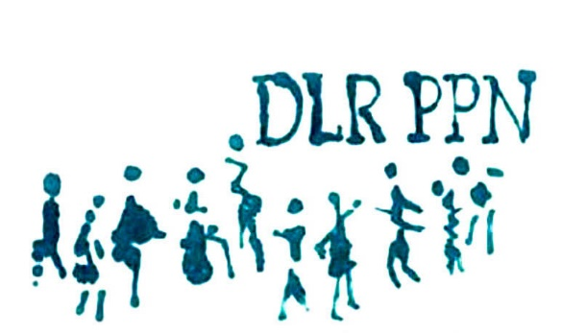
Dùn Laoghaire Rathdown
PUBLIC
PARTICIPATION
NETWORK
Submission form for motions regarding the operation of DLR PPN
Motions should be specific to the Governance, Operation, Structure, and/or Direction of the PPN with the intention of improving the effectiveness of the PPN.
Proposed motion (Brief outline of suggested action):

Submitted by (Name of PPN member organisation):
Contact name:
Phone: Email:

Reason for motion:

How would this action be carried out, and by whom?:

Approximate cost (if any):

Desired Outcome:

Signed: ___________________________ Position: __________________________________________
Email completed forms to secretariat@dlrppn.ie or post to DLR PPN, The Old Post Office, 7 Rock Hill, Main Street, Blackrock, Co. Dublin.

