DLR PPN Activity Report July 2023
_____________________________________________________

Project
DLR PPN Website – The new website went live in July, DLR Co Co provided images.
Member Directory – New facility on the website to raise the profile of member groups. Groups can now submit the group contact email, location, website and social media links etc to be displayed in the directory. See the Purple House entry for a good example. The group’s DLR PPN Registration Number is also displayed in this area.
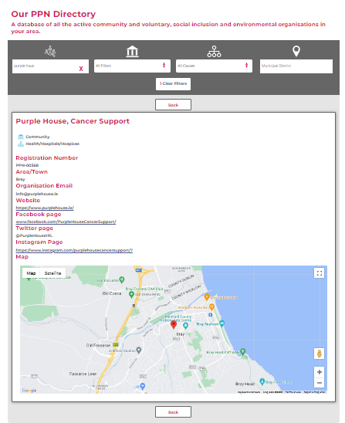

Secretariat Meetings
1 – July Secretariat meeting
1 – Finance Sub Committee meeting

Submission
Pre budget Submission made to DRCD

Radio programme
Community Connection Podcast - Guests - The Dublin Society of Model and Experimental Engineers, Purple House Cancer Support and The James Joyce Tower & Museum

Communications
July 2023 | Tweets | Facebook | Web Posts | Mass Email
Click here for the Ezine | 75 | 26 | 22 | 3

Governance
- Nomination opened for Rep on Planning & Citizen Engagement SPC.
- Election for new Planning and Citizen Environmental Pillar Rep held.
Election
- LCDC- there will be 2 vacancies from September 2023, one from Community & Voluntary Pillar and the other from Social Inclusion Pillar, the nomination process will open in mid-August.

Participation, Consultations and Surveys circulated to all membership.
- DLR PPN Member Update Contacts Request
- Children & Young Peoples' Consultation for New Arts Plan
- Living Streets - Coastal Mobility Route Consultations
- Deansgrange Flood Relief Scheme Survey
- Implementing the Hedge Code – Webinar
- Bat Conservation Ireland - Bat Survey Training
- DLR PPN July ezine is published.
- Divisional Garda National Youth Awards 2023
- Summer of Heritage 2023
- Draft Dundrum Local Area Plan
- Draft DLRCC Development Contribution Scheme 2023-2028
- Success at Monkstown Boxing Club
- Dublin Society of Model & Experimental Engineers
- Community Connection Dublin South FM
- Survey on the Draft PPN Implementation Roadmap
- Climate Conversation 2023 Consultation
- Women's Council of Ireland
- Dept. of Social Protection - Consultation on the Wage Subsidy Scheme
- Waterways Ireland - The Royal Canal
- EAPN Ireland - Pre Budget-Forum
- DLR Tourism - Dalkey Garden School
- Volunteer Ireland - Find your Local Volunteer Centre
- Dept. of Environment, Climate & Communications - Consultation on Disposable Vaping Devices
- Garda Info - Intake 232 Recruits
- DLRCC - Rochestown Avenue Part 8 Active Travel Scheme Consultation
- EPA Ireland - JunkKouture World Final
- Garda Info - Lost Dog Appeal
- Tuath Housing - Cost Rental Applications now open
- Carlow PPN - Carlow Garden festival
- The Wheel - Recruitment in Community & Voluntary Organisations
- ECO - UNESCO - Youth Action for Nature & Wellbeing Event
- Waterways Ireland - The Erne Waterway System
- Friends of the Earth - Moratorium on Data Centre Developments
- Climate Change Advisory Council Ireland - launch of the Council's Annual Review 2023
- Economic Development Office - Your Dublin, Your Voice Survey
- dlr Heritage - Free Guided Walking Tour of Milltown Village
- DLR PPN New Website & Member's Directory
- DLR PPN - Winter Plenary, Save the Date
- DLR PPN - Lets Stay Connected
- Public Survey to Inform an Action Plan for Youth Services
- Irish Environmental Network - July Newsletter
- Good Governance Awards
- Southside Partnership – Newsletter
- Barn Owl Live Stream - BirdWatch Ireland, South Dublin Branch
- NALA - Free Online Courses
- NALA - Being Literacy Friendly Webinar
- Environmental Protection Agency – Newsletter
- DLRCC Variation of Local Property Tax – Consultation
- The Library is the Place - New five-year strategy for libraries unveiled.

Funding information was circulated to all members.
- dlr First Frames Short Film Scheme
- dlr Festival of Inclusion 2023
- Dept. of Housing, Local Government & Heritage - Peatlands Community Engagement Scheme 2023
- Croí Cónaithe Refurbishment Fund
- Funding announced for the Irish Men's Sheds Associations

Community - Wellbeing information
- National Adult Literacy Agency - Free courses in Basic Maths
- Poetry at the Lexicon
- Rosemount Family Resource Centre - Schedule of Activities
- Training Centre, Loughlinstown - DDLETB Courses
- National Print Museum - Free Course in Cultural & Heritage Studies
- Adult Education Service South East DDLETB - Free Computer Courses
- Healthy Eating Resources for Older People
- The Bike Hub
- Irish National Sailing Club
- dlr Sports Partnership - BoxUp Sports equipment sharing
- Social Justice Ireland
- The Alzheimer Society of Ireland
- dlr Sports Partnership – Kayaking
- Healthy Ireland - Activities to keep kids active during school holidays.
- Age Action - Pre-Budget Submission
- DLRCC Coastival - Wing Summer Series
- dlr Sports Partnership - Coastival - Paddle Boarding
- National Numeracy – Dyscalculia
- Citizen's Information - UK State Pension Contributions
- Water Safety Ireland - World Drowning Prevention Day
- President of Ireland and The Irish Red Cross - Good Bike Scheme
- dlr Sports Partnership - Come On You Girls in Green
- Alone Ireland & the Irish Heart Foundation - F.A.S.T. Stroke Recognition
- dlr Sports Partnership - HEROutdoors Week
- Purple House - Cubs Programme
- Southside Partnership - Healthy Food Made Easy Course
- Southside Partnership - Living Well with Dementia
- Dublin Fire Rescue & Ambulance Emergency Service - Community Smoke Alarm Scheme
- Purple House - Relaxation Classes
- Purple House - CBT Techniques for the Management of Menopausal Symptoms
- CYPSC dlr - LetsLearnDLR & LetsTalkDLR Websites

